Code for Practical 5
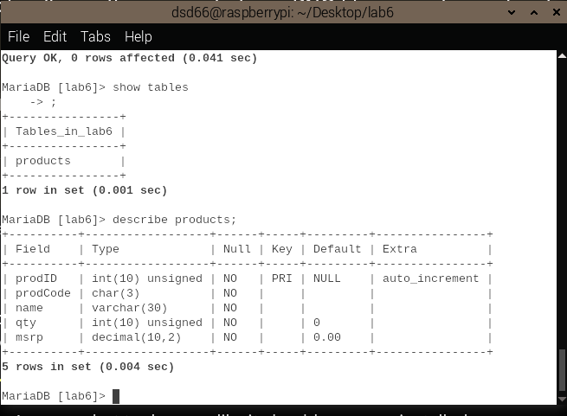
Figure 1: The 25.) SHOW tables and 26.) DESCRIBE products commands
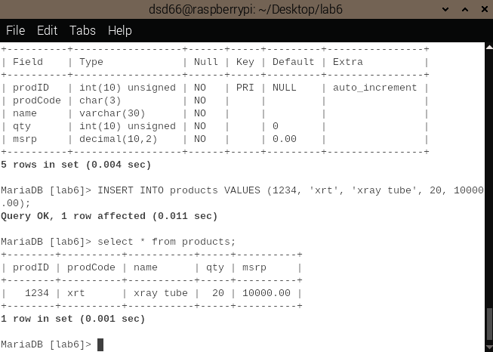
Figure 2: The 28.) INSERT INTO products command and its outcome
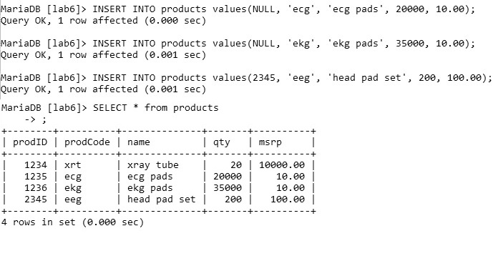

Figure 3: INSERT INTO commands for the next 3 rows (30.)

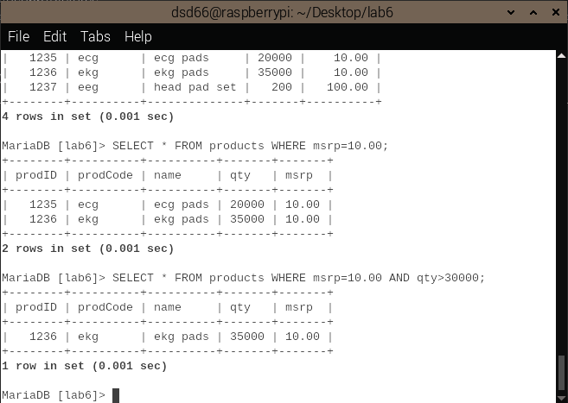
Figure 4: Filtered SELECT commands for 32.) and 33.)
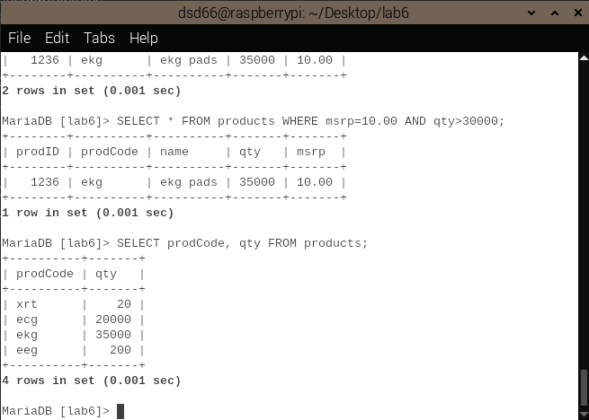
Figure 5: Column Filtering command for 34.)
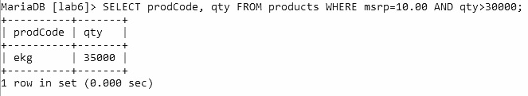
Figure 6: Filter Query for 35.)
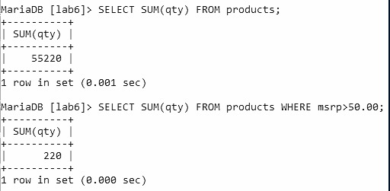
Figure 7: Filter Queries for 36.) and 37.)
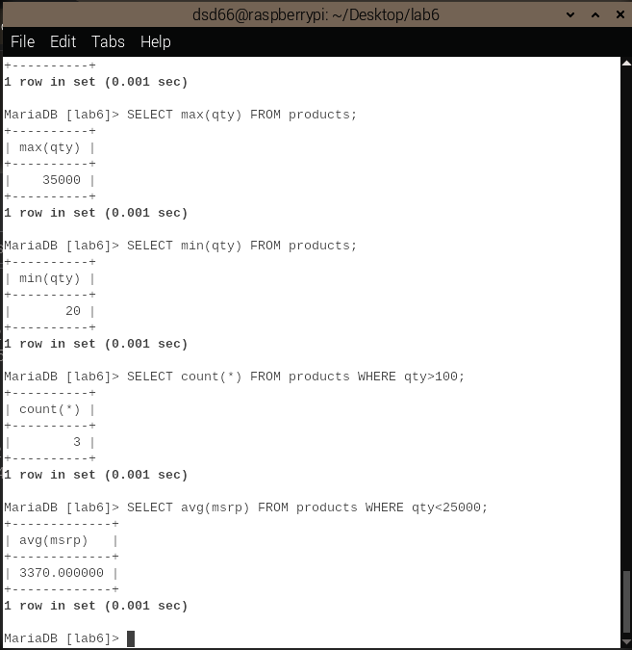
Figure 8: Filter Queries from 38.)
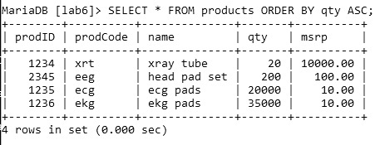
Figure 9: Filter Query from 39.)
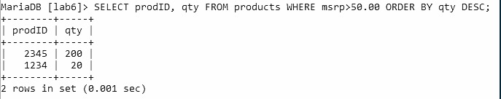
Figure 10: Filter Query for 40.)
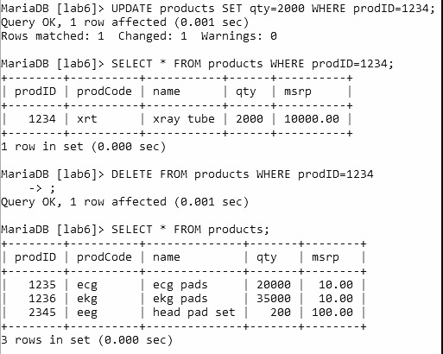
Figure 11: Query 41. )- 43.)
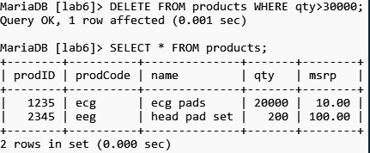
Figure 12: Query 44.) / 45.)
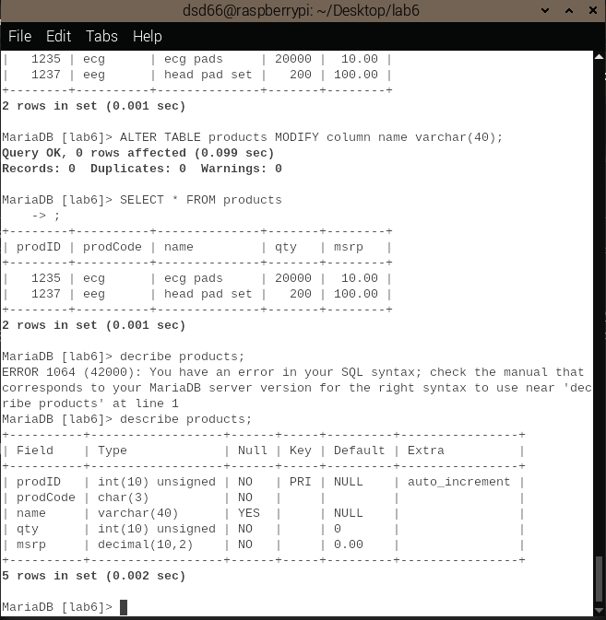
Figure 13: Alter Table command for 46.)
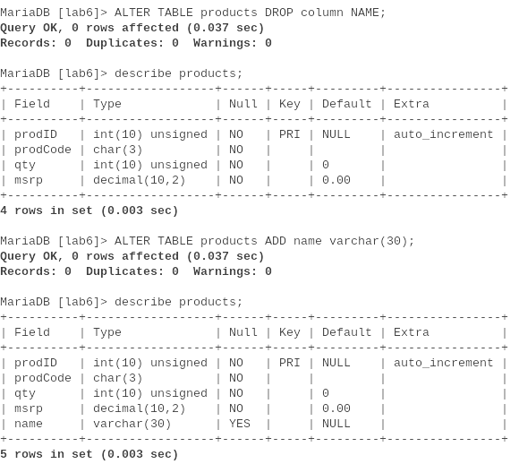
Figure 14: Drop column and Add Column commands for 48.) - 51.)
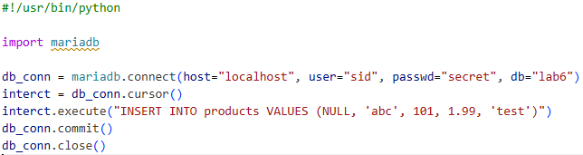
Figure 15: script6_1.py
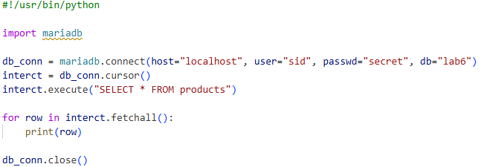
Figure 16: script6_2.py
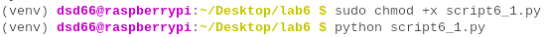
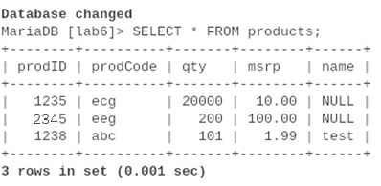
Figure 17: Running script6_1.py
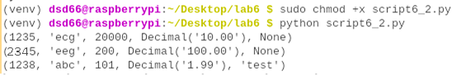
Figure 18: Running script6_2.py

